Investment proposal
"Production of bottled water»
The planned production capacity is 60,000 m3 per year

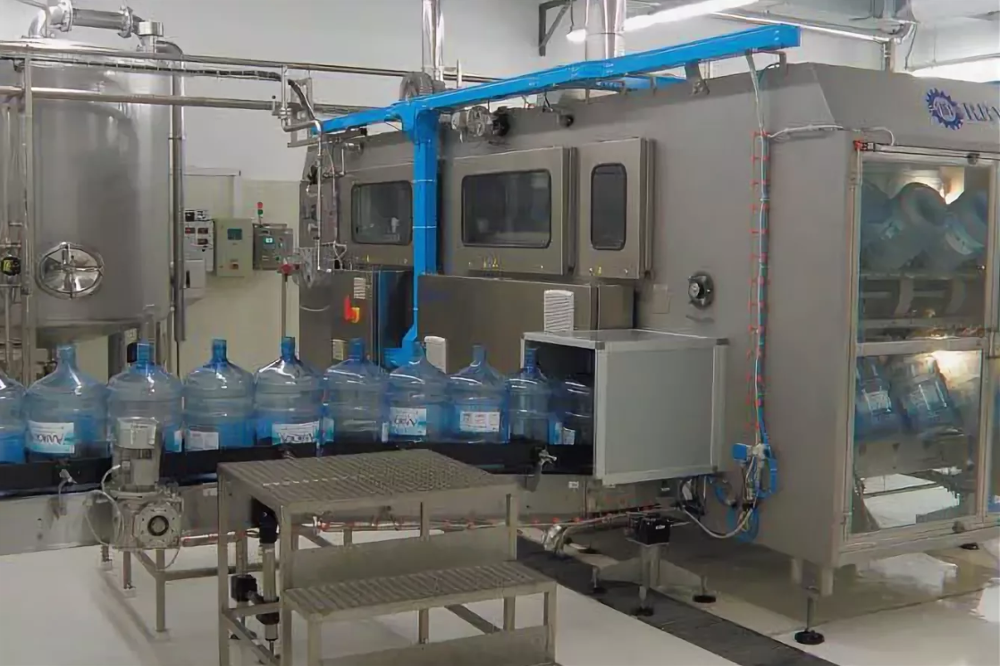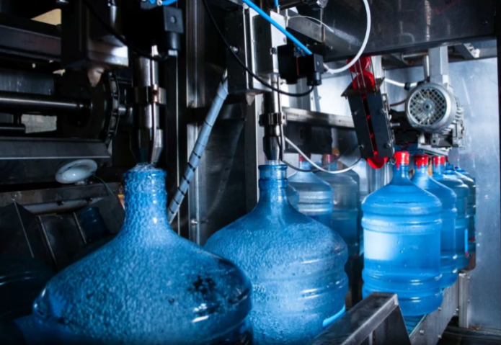
The estimated cost of performing these types of work will be 200 thousand US dollars
Payback period: 3 years
The investor's participation in project implementation: project funding

Feasibility of the project
- HIGH PROJECT PAYBACK
- POSSIBILITY OF CREATING PRODUCTION IN THE IMMEDIATE VICINITY OF THE WELL
- LOW COST

Planned product range for release:
- DRINKING WATER IN A PLASTIC CONTAINER WITH A VOLUME OF 5,10,19 LITERS

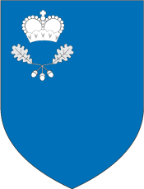
The main consumers
- Internal market of the Republic of Belarus
- European Union market
- CIS market

- MALORITSKIY DISTRICT EXECUTIVE COMMITTEE
- ADDRESS: Brest region, Malorita, Krasnoarmejskaja str., 1
- E-mail:
mal_econ1@brest-region.gov.by

- TEL:
80165120040 80165120054 80165120053 – fax

To implement the project, there is:
- Land plot in Malorita
- Railway station at a distance of 5 km
- 10KW power line
- Plumbing
- Gas-pipe
- Road at a distance of 300m

