INVESTMENT OFFER
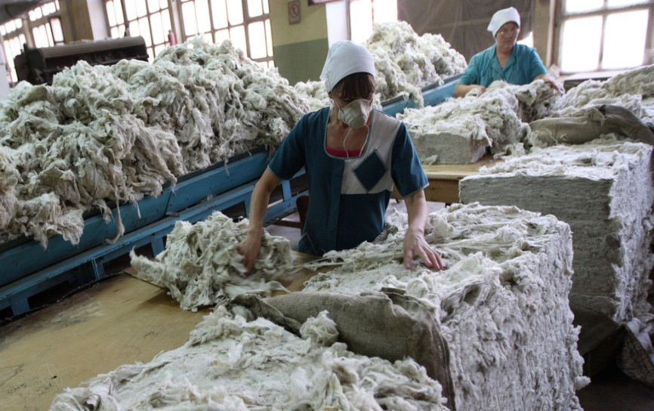
"ORGANIZATION OF PRODUCTION FOR PROCESSING OF WOOL COATS"
Investor participation form: direct investment
The result of the investment: the creation of a new enterprise with an approximate staff of workers - 4-5 people.
Location of the enterprise: Brest region, Lyakhovichsky district.
Approximate payback period: 3 years.

Expected capital investments: 140 thousand US dollars.
The main areas of investment use are: pre-project research and development of design and estimate documentation, construction of an industrial building, installation of engineering networks, purchase of: lines for washing and drying wool, loading equipment and auxiliary machinery.
Characteristics of the proposed buildings: a production workshop with an estimated area of ​​150 - 200 m2, storage rooms with an area of ​​200 m2, wastewater treatment plants with a capacity of 15-20 tons / day.

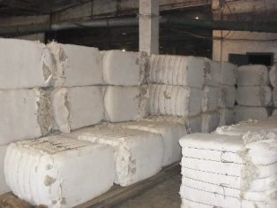
Characteristics planned for production: washed wool, pressed into briquettes weighing 70-80 kilograms and dimensions of 800x400x600 millimeters.
Consumers of products are industrial enterprises of the Republic of Belarus and the Russian Federation.

The advantages of the investment proposal:
- the presence on the territory of the region
of the existing sheep farm - JSC “Zherebkovichi”,
the number of sheep - 4000 units;
- state support (the action of the Decrees of the President of the Republic of Belarus No. 6 of May 7, 2012 and No. 10 of August 6, 2009, providing preferential tax treatment and exempting enterprises operating in small and medium-sized settlements from paying a number of compulsory payments and fees.

Contacts: +375 1633 21690, +375 1633 22962, E-mail: lhveconomrik@tut.by

